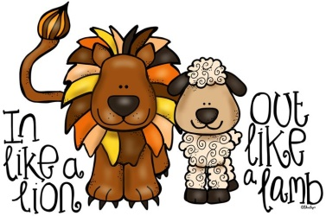
March 2025 Snack Calendar
Sunday | Monday | Tuesday | Wednesday | Thursday | Friday |  | Saturday
Reminder: We are Peanut & Tree Nut Free. Check labels. Only 100% juice, milk,  or water for drinks. |  |  |  |  |  | 1
2  Servings Needed:  Miss Tonya  AM – 18  PM - 17 | 3  Wyatt/Wade  ------  Bryce | 4  PS Supplied | 5  Ava/Gideon  ------  Charlie | 6  Campbell  ------  Charlotte | 7  Carl/Abraham  ------  Deacon |  | 8
9  Miss Amy 4’s  AM - 14 | 10  Claire/Andie  ------  Ellie M | 11  Brooks  ------  James | 12  Crew/Carson  ------  Elyse | 13  Hudsen A  ------  Kaile | 14  Dom/PS Sup.  ------  Gabe |  | 15
16  Miss Amy 3’s  AM – 14  PM – 9 | 17  PS Supplied | 18  Leo  ------  Laiklyn | 19  Ellie S/Harper  ------  JJ | 20  Lilly  ------  Tripp | 21  Graham/Henry  ------  Kael |  | 22
23  30 | 24  Hendrix/PS  ------  Kyren  31 No School | 25  PS Supplied | 26  Hudson M/Hudson B  ------  Lela | 27  PS Supplied | 28  Jack/Julia  ------  Lincoln |  | 29

